Understading dataset

<https://cs.nyu.edu/~roweis/data.html>

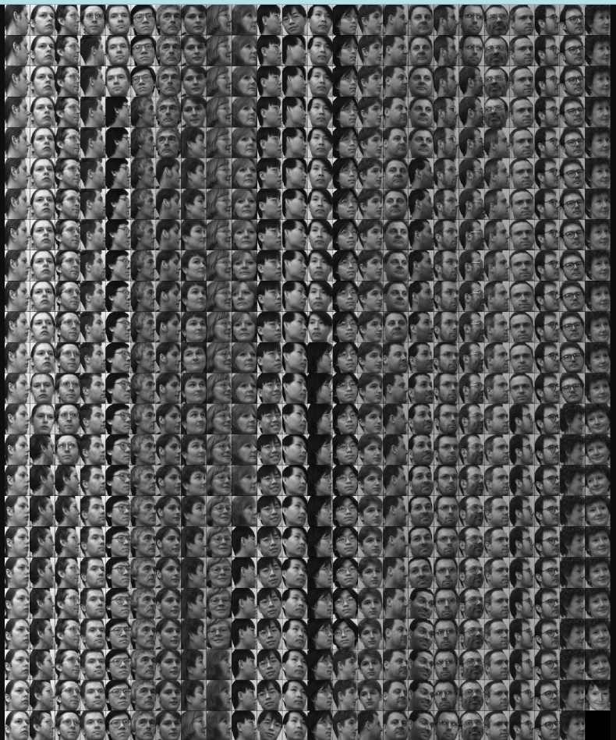

We have a dataset with a sample of 20 people pictures.

Images are displayed in grayscale 8 bit [0-255], with a size of 112 x 92.

we have a group of matrices grouping the number of images per person this with different views.

Number images for person

<https://cs.nyu.edu/~roweis/data.html>

<https://cs.nyu.edu/~roweis/data/umist_cropped.jpg>